**Project 1**

**Flask Ci-Cd pipeline**

**1) Setup a Simple Flask App**

**Project Structure**

my-flask-app  
│── app.py  
│── requirements.txt  
│── Dockerfile  
│── Jenkinsfile

**app.py**: The main Flask application file.

**requirements.txt**: List of dependencies (Flask and others).

**Dockerfile**: Defines the Docker image for the Flask app.

**Jenkinsfile**: Contains the Jenkins pipeline configuration.

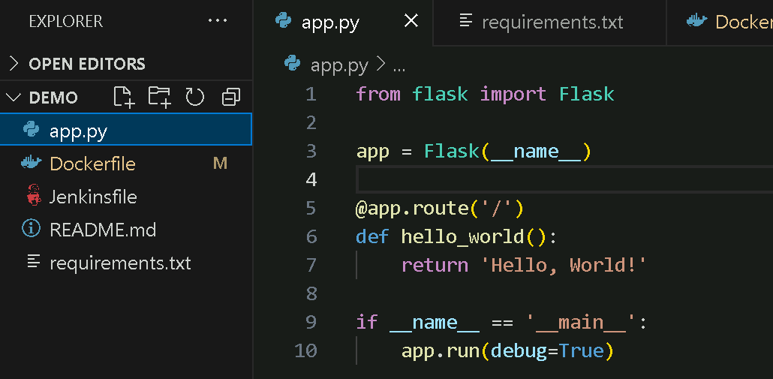

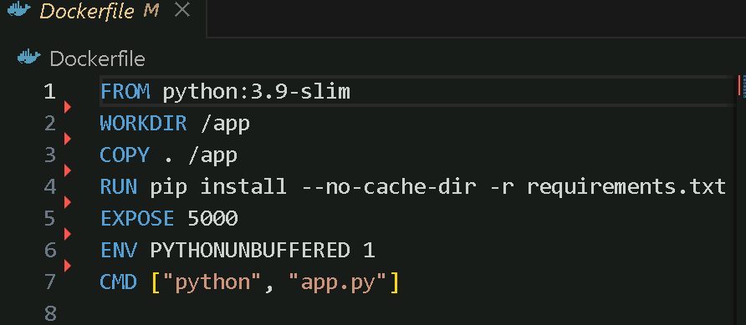

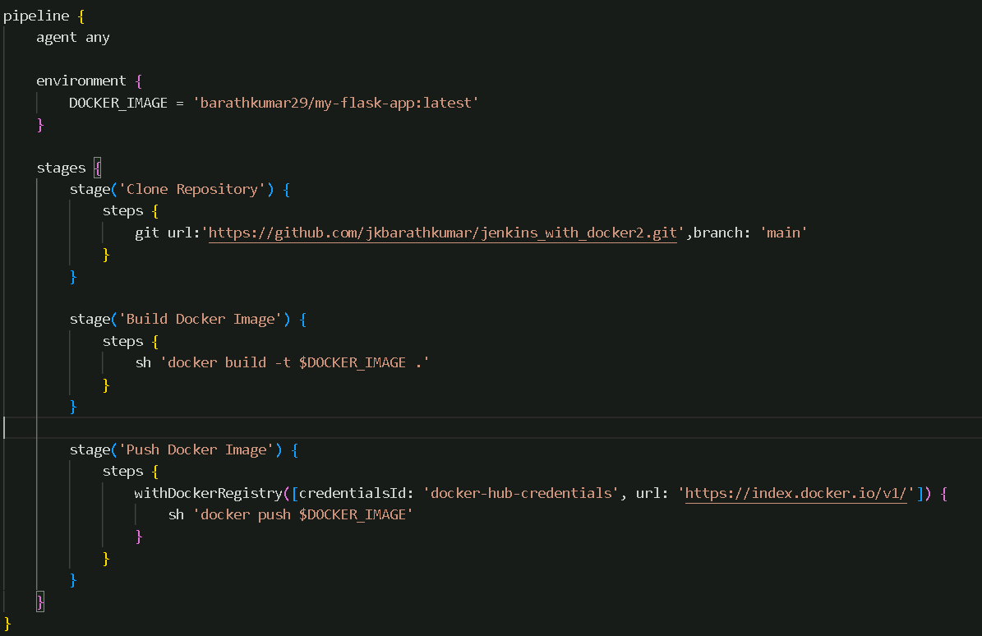

**Github link for the code:** [**jkbarathkumar/jenkins_with_docker2**](https://github.com/jkbarathkumar/jenkins_with_docker2)

**2. Push the Code to GitHub**

* **Make sure you have a GitHub repository created for the project.**
* **Push all the files (app.py, requirements.txt, Dockerfile, Jenkinsfile) to the GitHub repository**

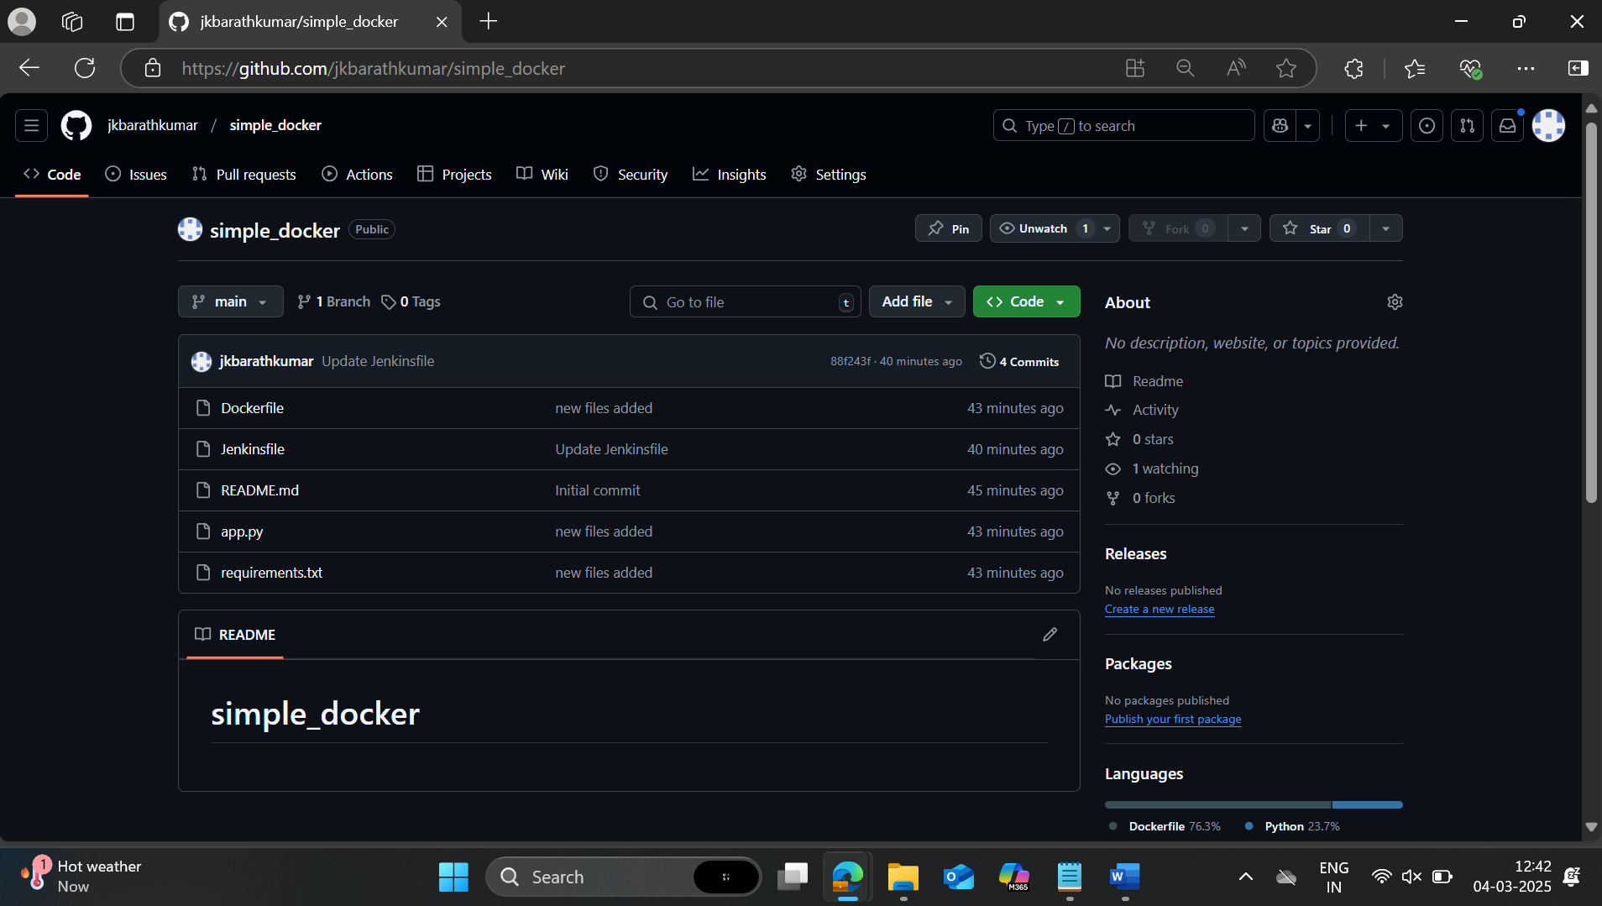

**3. Configure Docker Hub Credentials in Jenkins**

* **Go to Jenkins > Manage Jenkins > Manage Credentials.**
* **Add new credentials:**
  + **Username: Your Docker Hub username.**
  + **Password: Your Docker Hub password (or token).**
  + **ID: Name it something like dockerhub-creds (the same name used in the Jenkinsfile).**

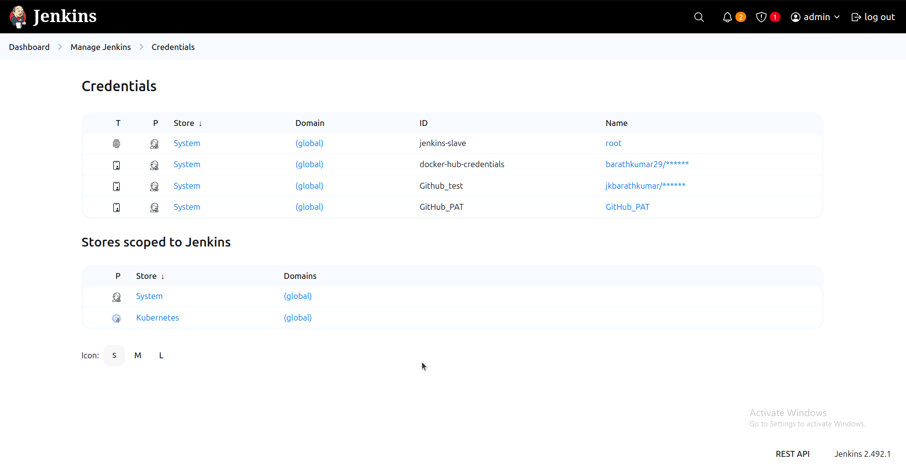

**4. Create a New Pipeline in Jenkins**

* **In Jenkins, click New Item > Pipeline.**
* **Enter a name for the pipeline.**
* **Under Pipeline Definition, select Pipeline script from SCM.**
  + **Select Git as the SCM.**
  + **Enter the GitHub repository URL (https://github.com/your-username/my-flask-app.git).**
  + **Set the branch (typically master or main).**
* **Click Save.**

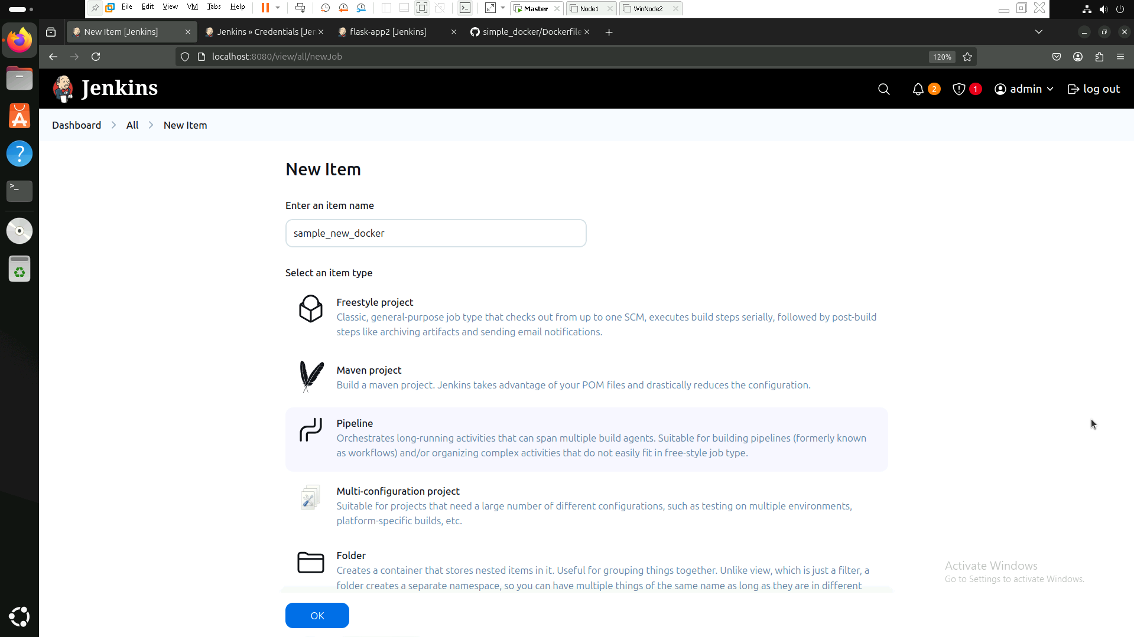

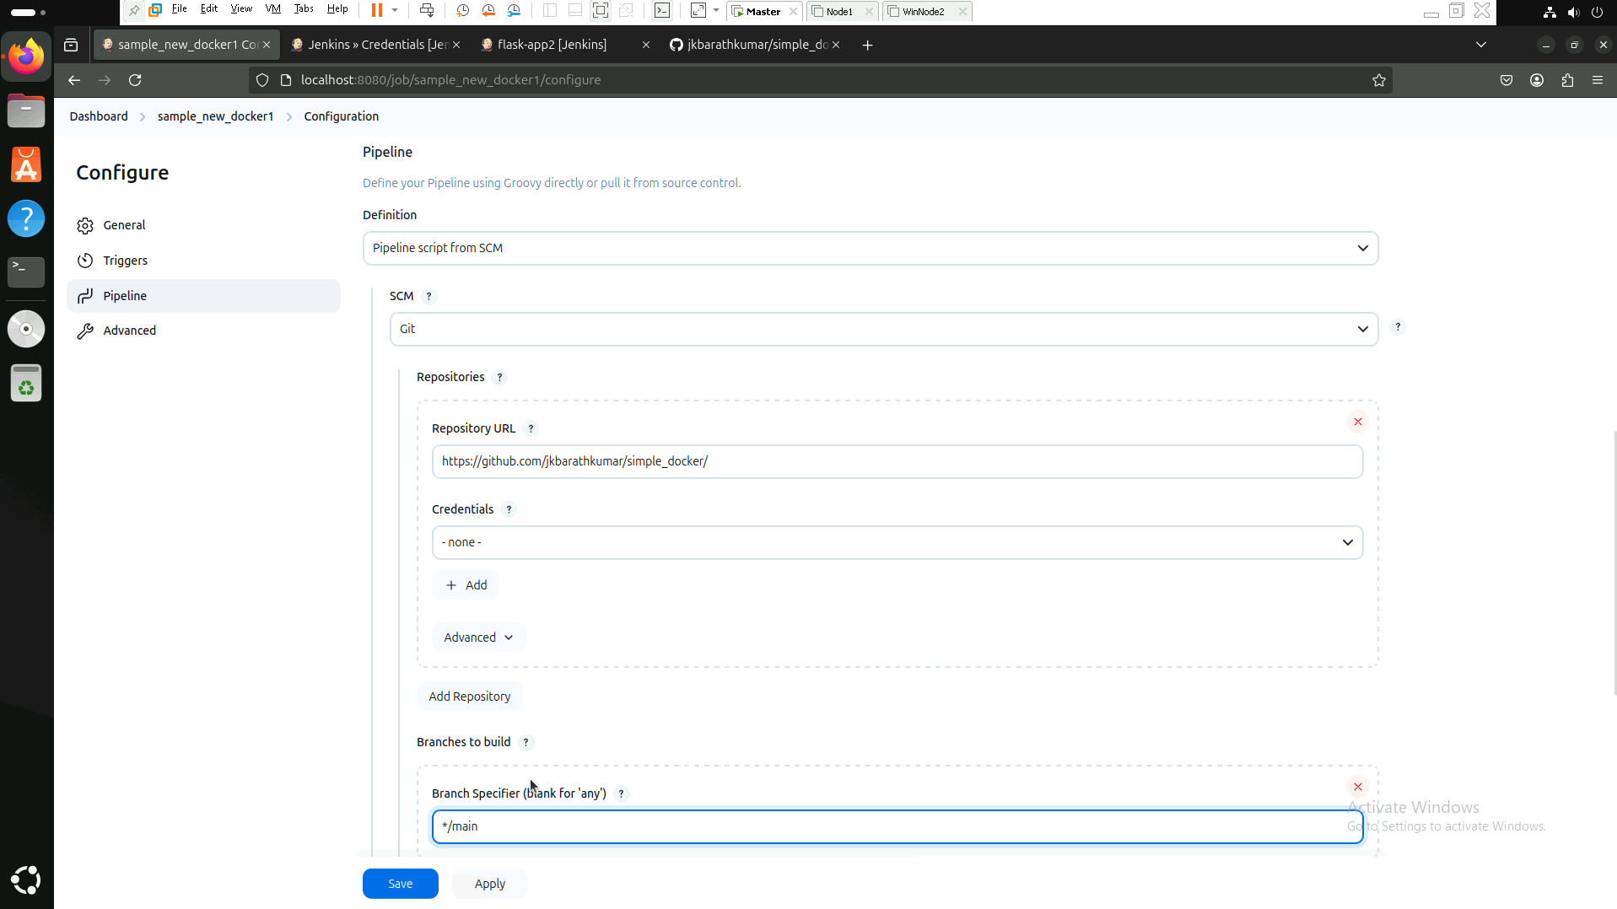

**5. Click Build Now**

* **Click Build Now in Jenkins to trigger the build.**
* **Jenkins will:**
  + **Checkout the code from GitHub.**
  + **Build the Docker image.**
  + **Push the image to Docker Hub.**

